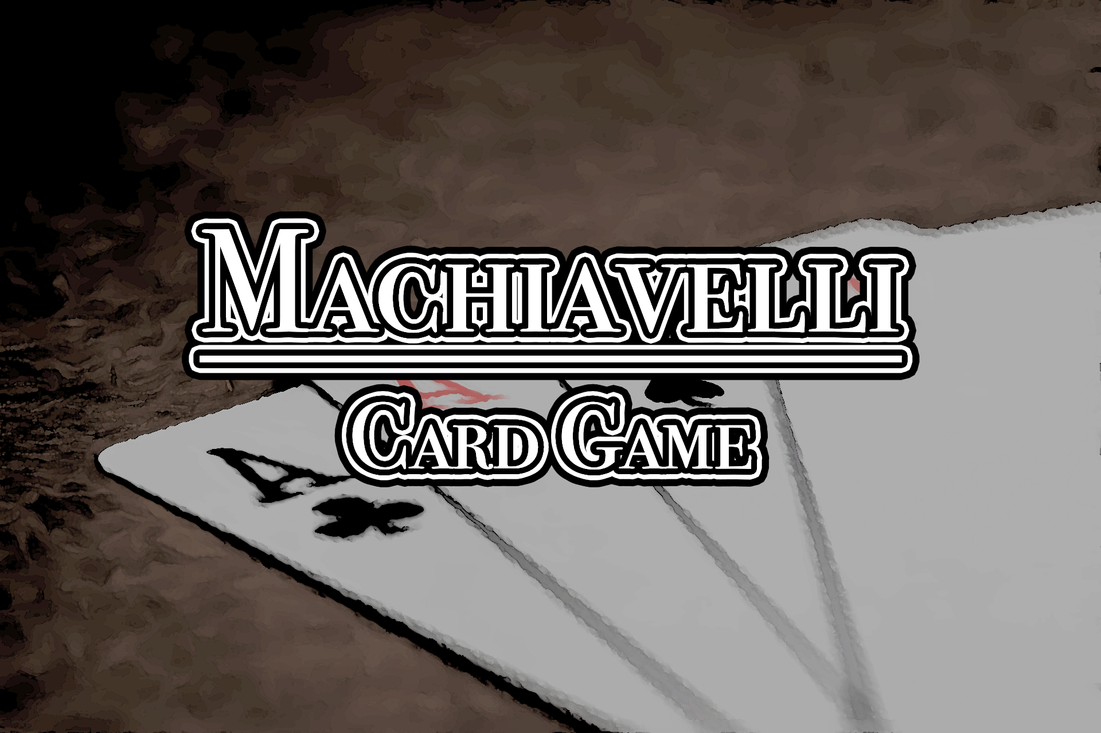

Machiavelli User Manual

**Siraj Ahmadzai**

**Under Guidance of**

**Professor Jean-Pierre Corriveau**

**Table of Contents**

**Organization of the Manual 3**

**What is Machiavelli? 4**

**Game Overview 5**

**System Requirements 6**

**Hardware 6**

**Software 6**

**GETTING STARTED 7**

**Compiling from source 8**

**Gameplay 10**

**Starting up server 10**

**Joining a game 11**

**Rules of play 12**

**Moves 13**

**Leaving the game 13**

**Troubleshooting 13**

# Organization of the Manual

The user manual consists of 4 sections:

* Introduction
* System Requirements
* Getting Started
* Gameplay

Introductory section explains in general terms the system and its intended purpose. It also gives a brief overview of the actual game and its characteristics.

System Requirements section provides a general overview of the system required to run the program successfully.

Getting Started section explains how to get Machiavelli running on your system along with all the prerequisites necessary.

Gameplay section provides a detailed description of how the game is started, the creation of a server and how the game is played, along with all of its rules and regulations.

# What is Machiavelli?

Machiavelli is an Italian card game, derived from Rummy, usually played by 2 to 5 players, but can be played by more. It is a party game played by many across the world.

Its appearance among card games can be traced to the Second World War.



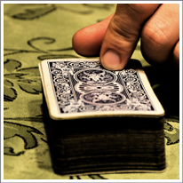

Play requires two decks of 52 standard playing cards, excluding the jokers. The main objective of the game is to play all the cards in your hand.

## Game Overview

This game works perfect with 2 or 4 players in LAN mode, or over the internet. It is a turn based game in which you are either dealt the cards at the start of the game or you have to pick them up from the deck under certain conditions. You have to play all the cards in your hand to win the game.

This version deals 15 cards at the start to each player.

The defining feature of Machiavelli is being able to make changes to the combinations of cards already on the table. You may reorganize the cards or add to the ones already on the table in order to make new combos that make it easier to play one or more cards in your hand. All new combinations must be valid, and players cannot remove any cards already on the table.

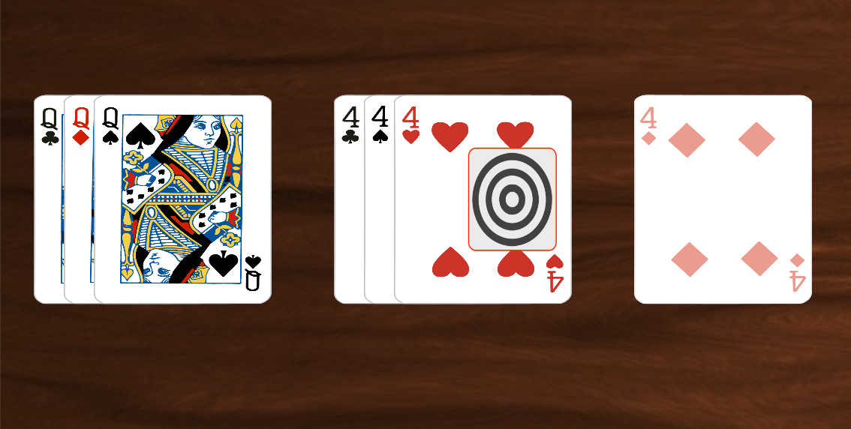

Adding new 4 card to the existing combo on the table.

# System Requirements

## Hardware

This application can run on any modern platform supporting java.

We recommend at least:

Minimum 100Mb free hard drive space.

256Mb or Higher of RAM

Dual Core or Higher Processor

Keyboard

Mouse

## Software

The latest stable release of Java Runtime Environment.

# GETTING STARTED

To get Machiavelli on your machine, you just need to download Machiavelli package and make sure that the latest Java is installed.

**Getting the game**

The game is packaged in a jar file which is available to download and execute directly on any OS supporting JRE.

Once you have downloaded the file, you will have a Machiavelli.jar file. Follow the instructions below to start the application.

**Running the game**

* If your OS supports native execution of Jar packages, double click on the file icon to start the application.
* Else, open a command prompt and type the following:
  + $ cd <Game Directory>
  + $ java -jar ./Machiavelli.jar

If you get an error about java command not being found, you need to install Java. Follow the instructions below to get the latest Java for your computer.

**Installing Java**

Most of the pc’s have java already installed, but if you are unable to start the application, follow the instructions below to get Java.

* Go to <https://www.java.com/download/> and download the latest version of Java Runtime Environment for your OS.
* Double click the downloaded file to start the setup wizard.
* Read the instructions and click next to continue.
* Once the setup has finished, click close to exit the wizard.

## Compiling from source

You need Maven installed on you pc to compile the app. Open a terminal window and navigate to the project directory, then use the following commands

$ mvn compile

$ mvn package

$ mvn package -DskipTests

This will generate a jar file that is executable by double clicking if your OS supports or by using the following command:

$ java -jar <path_to_jar>

**Maven**: https://maven.apache.org/guides/getting-started/

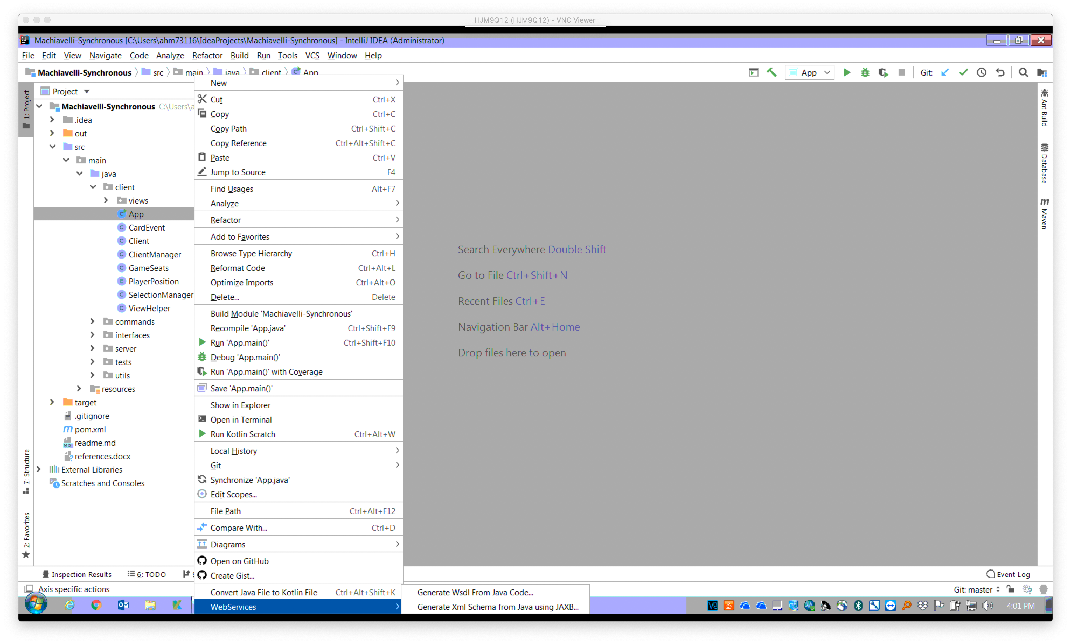**Running from IntelliJ Idea**

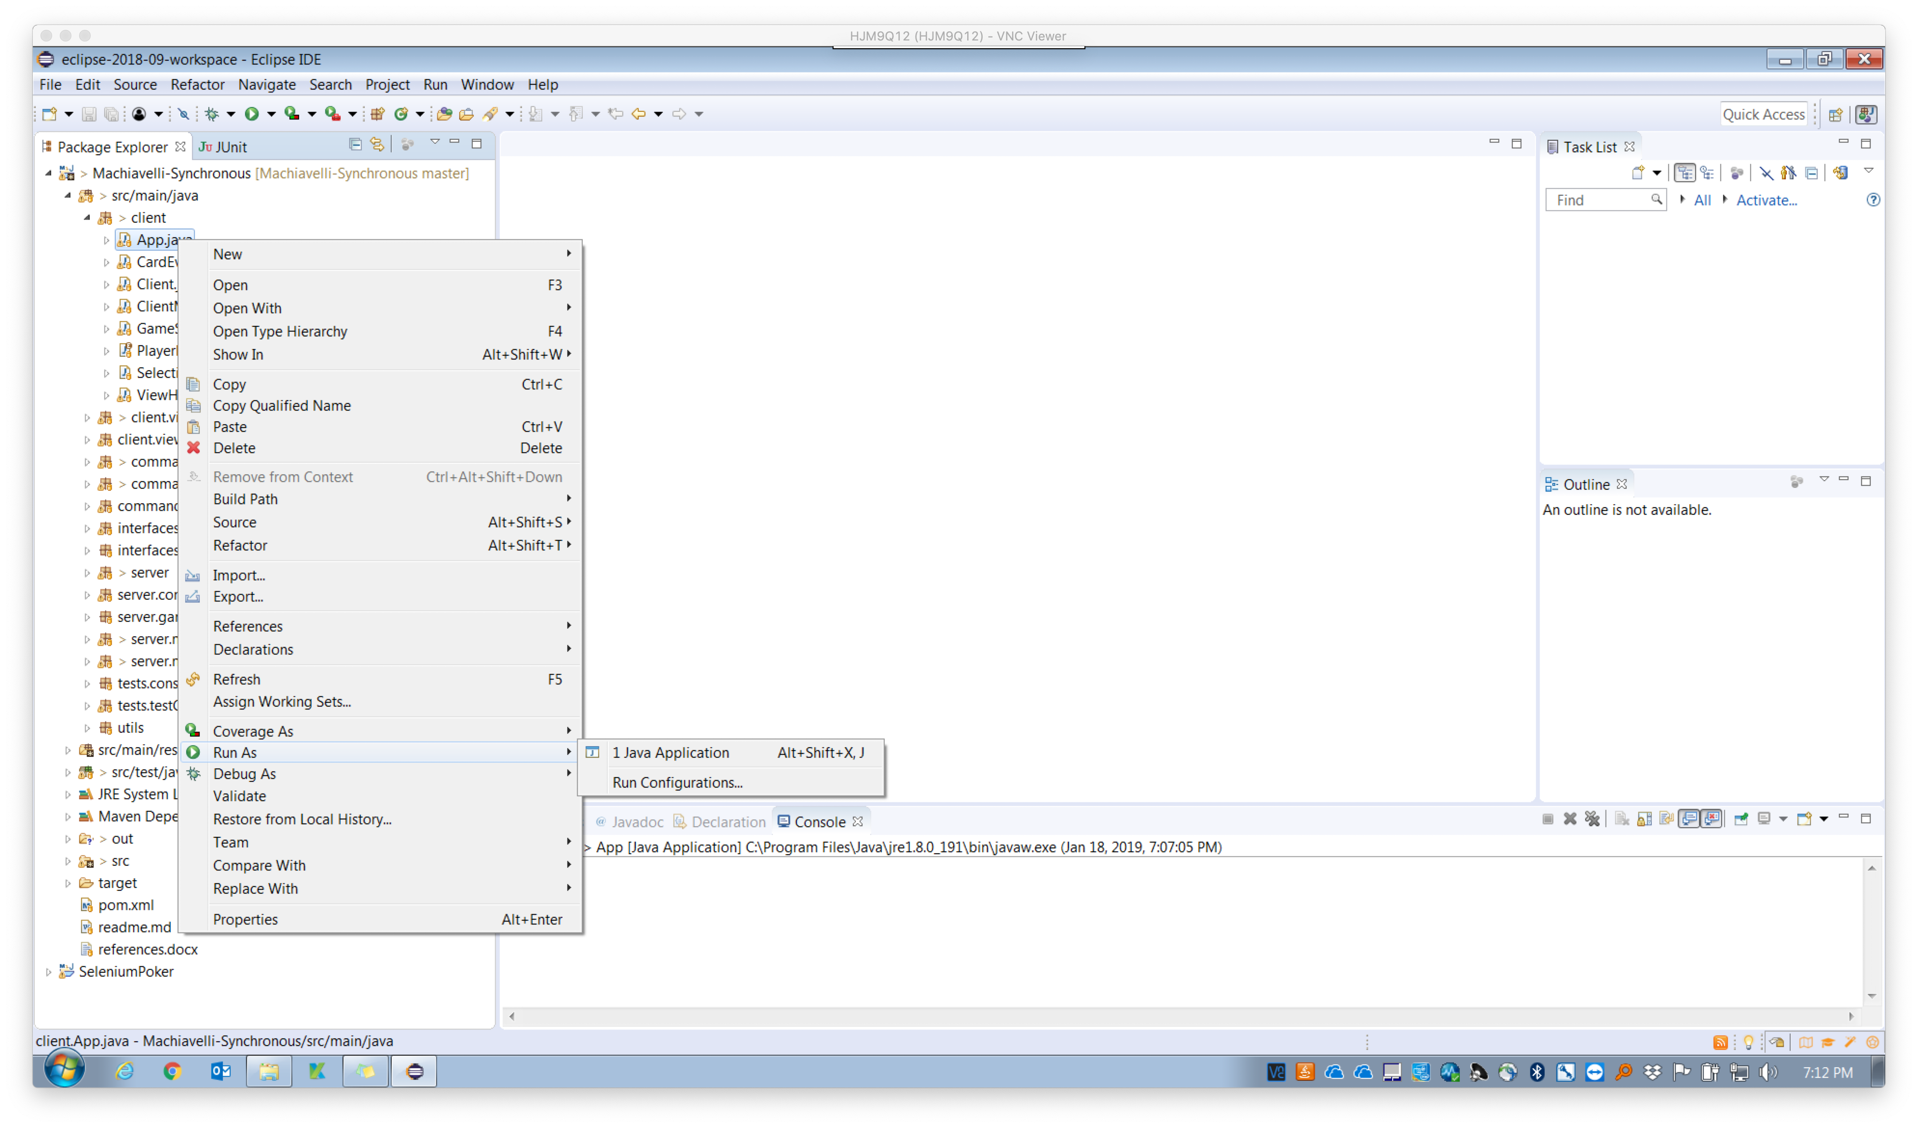**Running from Eclipse**

Once the project has finished loading, right click on the App class as shown above and select “**Run App.main()**” to start an instance of the application.

Other IDE’s have a similar process to run the main method. Just start with the App.main()

# Gameplay

## Starting up server

When you start the application, you will see two tabs, one for starting the server and one for joining game. If you want to start the server you need to provide valid IP and free port number along with number of players that will join the game and just click on start server, if port is not free on given IP and given port number it will give you message that port is already in use. You also need to provide your username which will be visible inside the game

## 

## Joining a game

Next to Server tab there is join game tab which will allow you to connect to an already started server on your network. Here you only need to provide valid credentials of the server you want to 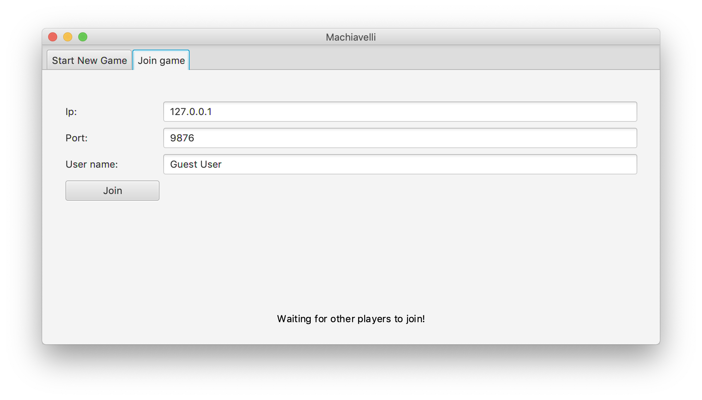play upon.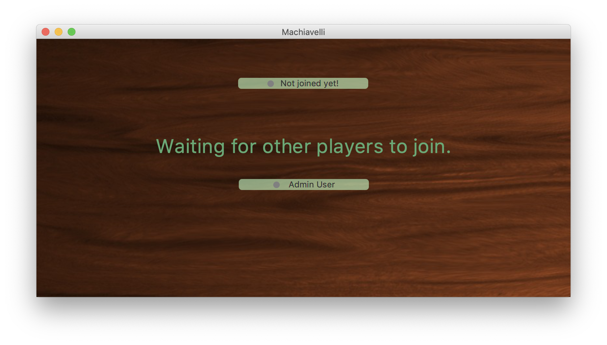

Once the server is configured properly, it’ll wait for the players to join.

## Rules of play

**There are three main actions that the player can decide to play:**

* Play a valid combination of cards on the table.
* Add one or more cards to an existing combination of cards.
* Draw a card from the deck if you don't play any cards.

**Valid combination means:**

* Three (or four) of the same card, but different suits (example: 7♥ 7♦ 7♠)
* A straight of at least three consecutive cards of the same suit (example: 3♠ 4♠ 5♠)
* Adding one or more cards to a combination on the table (example: adding 2♠ to 3♠ 4♠ 5♠, and/or adding 7♣ to 7♥ 7♦ 7♠)
* When finished, the current player passes the game to the player on his left, and should not draw a card. A player who fails to place any cards on the table must draw the top card from the deck and end his turn.
* The player who manages to play all the cards in his hand wins the game.

## Moves

Player can play moves by clicking on Meld or Deck one must play a valid move in order to pass turn to opponent. If you want to redo you move before you have finished it, you can click on the 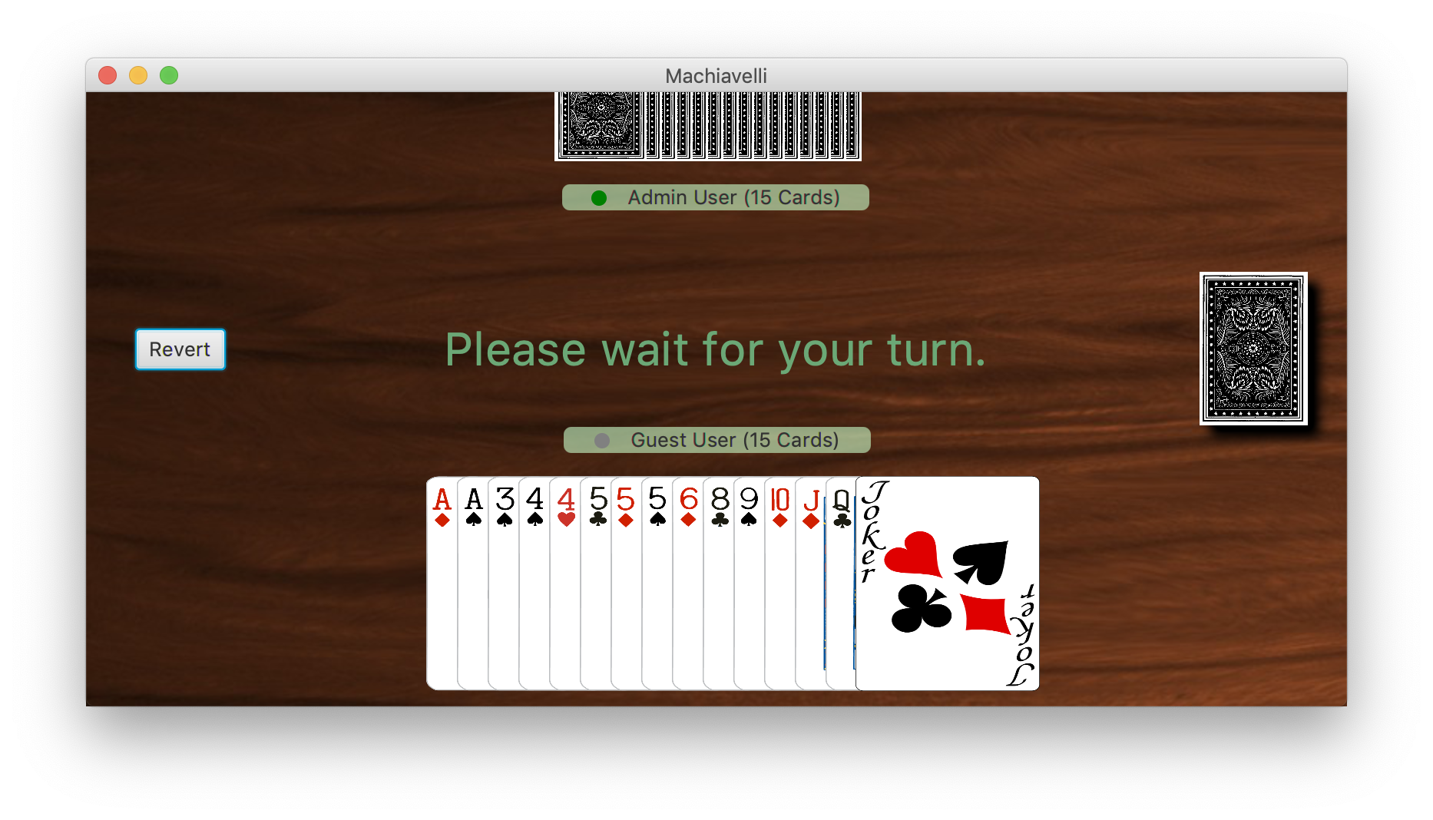revert button.

A standard game table.

## Leaving the game

To exit the application, you just need to close the application and it will drop you out from the current running game and stop all instances running on your machine.

# Troubleshooting

If you encounter any error during setup or while playing, make sure that the latest version of java is installed on your OS.

If the error still persists, run the game through the console and look for any errors and relevant instructions that are reported there.

If the errors still cannot be resolved, contact me for immediate support.